Final Project
NYC Rent Market: Analysis of Structural Price Drivers
Ya-cheng Hsieh
Quantitative Methods for Business Analysis

EXECUTIVE SUMMARY
The New York City rental market reveals a highly complex structure shaped by pronounced geographic disparities and long-term temporal shifts that simple descriptive or bivariate methods cannot sufficiently explain. To establish a rigorous baseline model of rental price dynamics, this project integrates descriptive diagnostics with a multivariate regression framework, enabling the analysis to move beyond surface-level associations and identify the structural forces that truly drive rent variability across the city.
The descriptive profiling highlights the strong right-skewness of rental prices, a pattern evident in the wide spread between the lowest and highest rents as well as substantial variability across boroughs. Because the mean is disproportionately influenced by luxury outliers common in Manhattan, the median emerges as a more reliable and resistant statistic for capturing the city's “typical” rental level. This approach ensures that the baseline analysis reflects genuine market conditions rather than extreme values that distort central tendencies.
At the same time, simple correlations reveal that no single predictor meaningfully accounts for rent variation. Although median rent is statistically associated with inventory, month, and time trends, these relationships are exceedingly weak (e.g., |r| < .10). Their statistical significance is largely a function of the large sample size (N = 24,477) rather than substantive explanatory power. This illustrates a classic statistical paradox, in which variables appear significant despite having negligible effect sizes—an important caution for decision-makers who may otherwise overinterpret weak signals. Furthermore, Levene’s Test (F = 1409.505, p < .001) indicates significant heterogeneity in error variances across boroughs, reinforcing the need for analytical techniques, such as HC3 robust standard errors, that can account for such data irregularities.
Given these limitations, a multiple linear regression model was employed to more fully capture the interdependent drivers of rental pricing. The final model demonstrates strong explanatory performance, accounting for 45.7% of the overall variation in median rent (R² = .457)—a high level of explanatory power for urban economic data. The regression results underscore the dominant influence of structural geography: borough effects were highly significant (F = 5703.584, p < .001), with adjusted mean rents revealing a clear hierarchical pattern—Manhattan ($3726), Brooklyn ($2638), Queens ($2107), and the Bronx ($1794). The gap between Manhattan and the Bronx (approximately $1932) represents the most striking structural disparity in the dataset.
Temporal variables also exhibit meaningful explanatory value. TimeIndex (B = .005, p < .001) and Year (B = 86.038, p < .001) both indicate sustained upward trends in rental prices over time. Notably, the Year coefficient implies that, after controlling for borough and other factors, average rents increase by roughly $86 annually, illustrating the persistent inflationary pressures in the market. To enhance interpretability and mitigate the skewed distribution of rents, log-transformed dependent variables (LogRent) were incorporated, enabling coefficients to be understood as percentage changes, a format especially valuable for strategic planning and cross-borough comparisons.
Collectively, the results demonstrate that rental prices in New York City are shaped not by short-term inventory changes or simple seasonal fluctuations, but by deep structural forces—most prominently, geographic location and long-term temporal progression. Descriptive and bivariate methods serve as useful starting points, but only a multivariate framework can uncover the true dynamics governing rent behavior across the city’s heterogeneous landscape.
Strategic recommendations emerge directly from these findings. First, pricing and policy decisions should adopt a location-specific approach, recognizing that borough-level differences account for the majority of rent variation. Second, future forecasting efforts should prioritize geographic characteristics and long-term temporal indicators rather than weak, low-impact variables such as inventory or monthly fluctuations. Finally, decision-making should emphasize effect size over statistical significance, ensuring that strategies are grounded in substantive, meaningful predictors rather than artifacts of large sample sizes.

DATA PREP
- Finding Data files: https://streeteasy.com/blog/data-dashboard/[object%20Object]
- Data Wrangling:
  - Analyze data:
    - have the same structure, use the same ZIP code / neighborhood / borough, have dates from 2010–2025, included in the column/row data
    - Establish variables: Rental inventory = number of rental units available for rent in that month for that neighborhood/submarket (independent variable), Median Rent (dependent variable)
    - Using median_rent file and inventory file
Goal: To see whether rent increases over time and compare trends between neighborhoods.
  - Data Cleaning:
    - Make sure the first row is the actual header
    - Delete any blank rows above the header.
    - Confirm date columns look like: 2010-01, 2010-02 (long dates)
    - Make columns (areaName, Borough, areaType) text
    - Load data into power query
    - Establish 1st row is as header
    - Unpivot Columns
    - Merged two datasets
    - Rename columns
    - Save new file to load to SPSS

VISUALIZATION
Frequencies- for Categorical variables
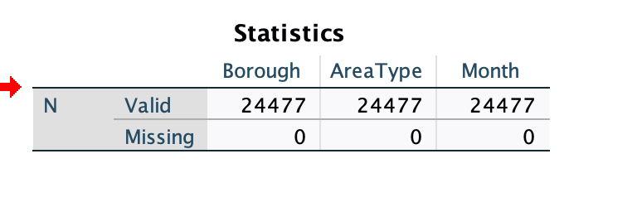
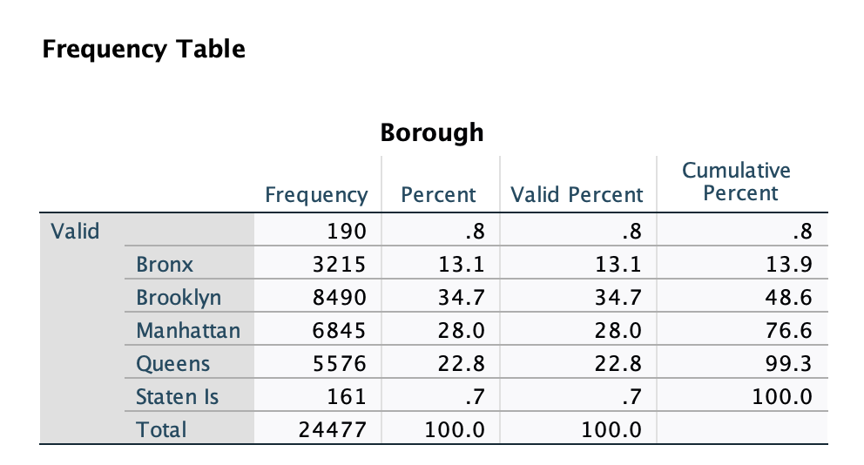

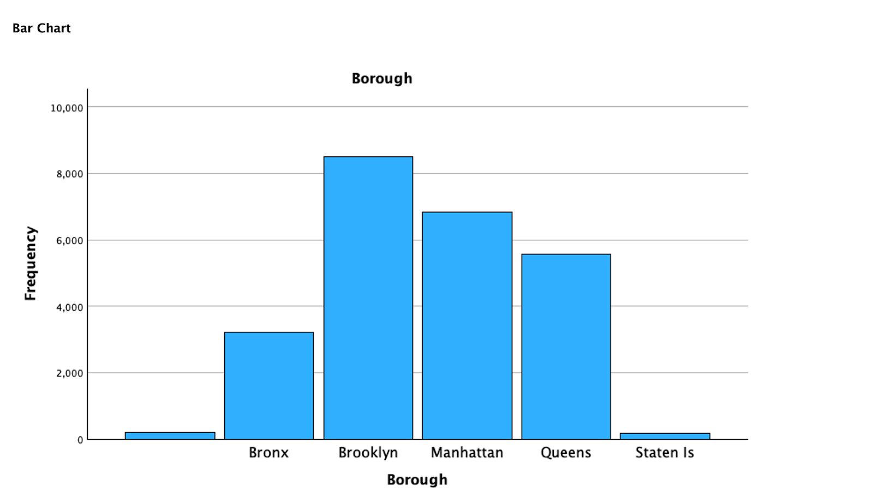
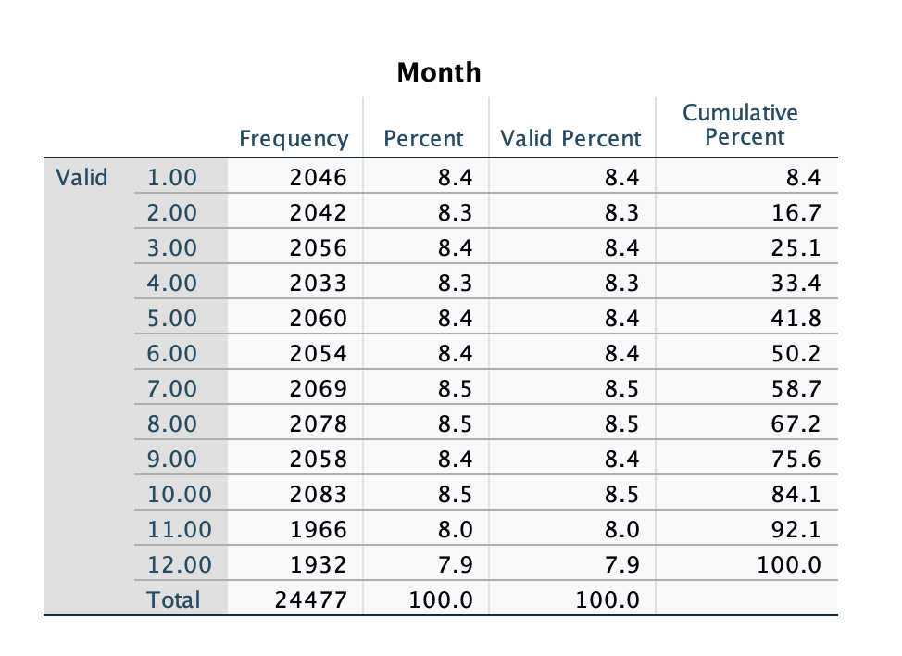

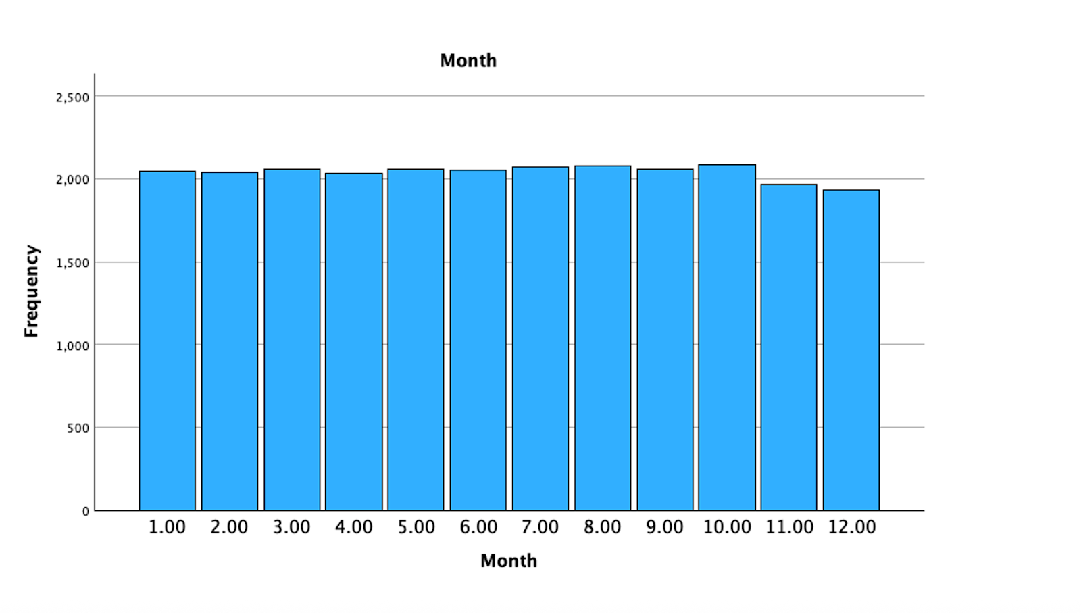
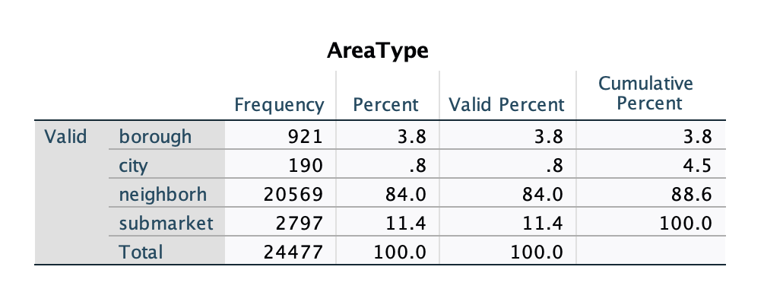

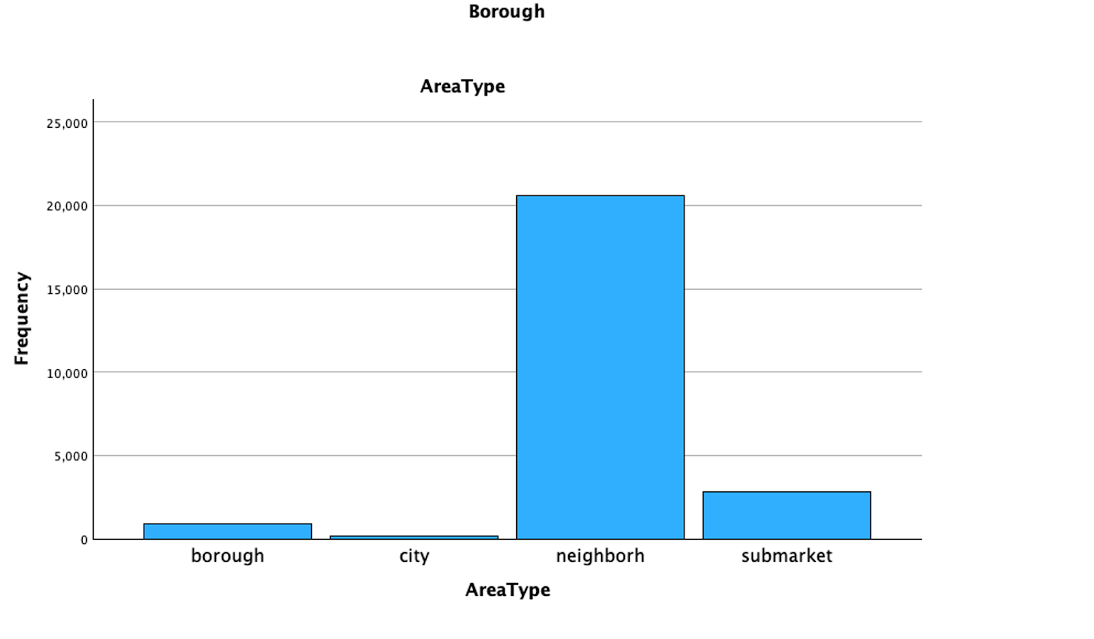

Descriptive statistics for quantitative variables

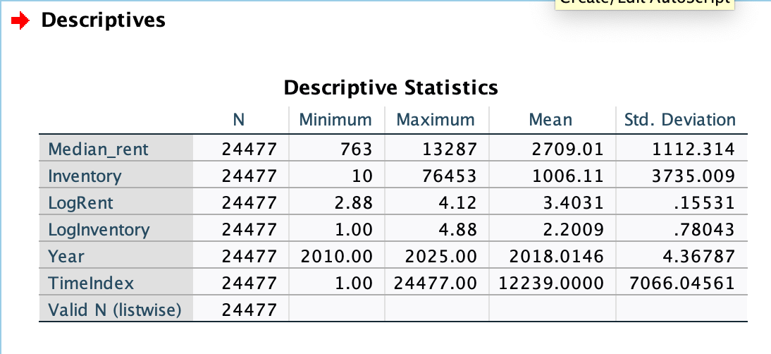

Descriptives by Borough
Average rent by borough: Mean rent per borough
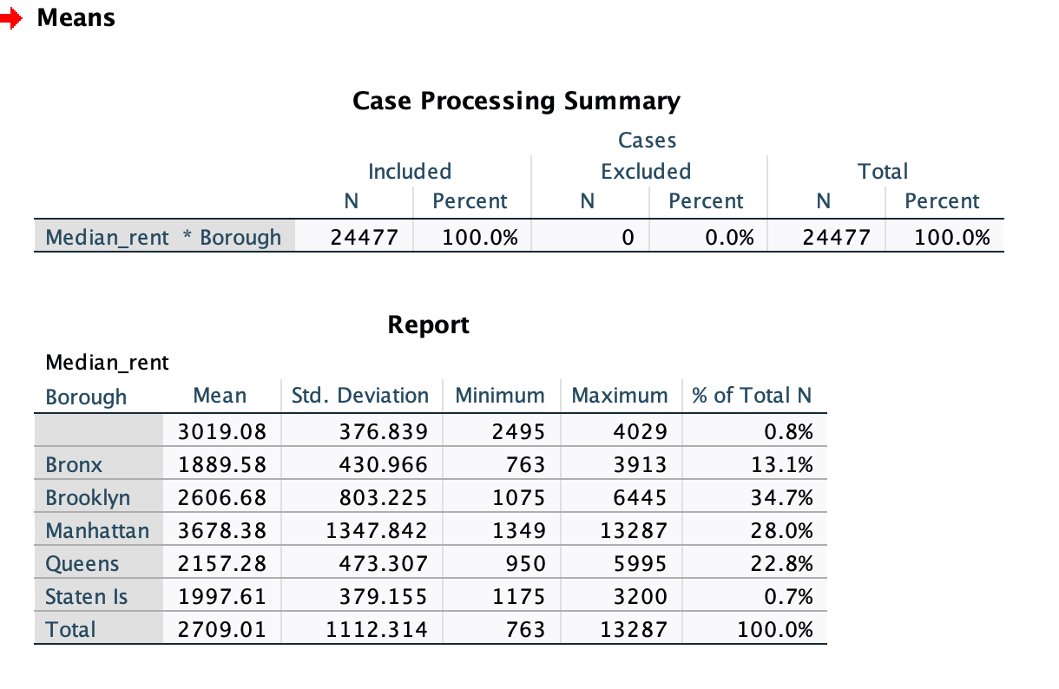

Regression Modeling
Question to answer: “How does rent change over time across NYC neighborhoods?”
- MedianRent (or Rent)/Inventory/TimeIndex (numeric time trend)/Borough_code (dummy-coded or numeric)/Month
- Dependent variable: Median_rent
- Independent variable(s):Inventory/ TimeIndex/ Borough_Code
Meaning of each Variable:
LogRent: In regressions, it lets you interpret results as percentage changes.
Taking the log:makes the distribution more normal, stabilizes variance, makes regression coefficients easier to interpret
LogInventory: reduces skew, makes the trend smoother, improves regression fit (Often used when testing whether inventory affects rent:)
Borough_code:A numeric version of the Borough variable.
1 = Manhattan, 2 = Brooklyn, 3 = Queens, 4 = Bronx 5 = Staten Island
TimeIndex: A variable that counts time in order:
1 → first month, 2 → second month, 3 → third month….
It allows you to measure trend over time in regression.
Time:Allows smoother time trend analysis than TimeIndex, Lets you interpret trends per year, not per month index.
Month (numeric 1–12): Helps check seasonal patterns, Useful for descriptive statistics:Does rent peak in summer?Does inventory drop in winter?

Checking Correlations:
- Variables: MedianRent (or Rent)/Inventory/ TimeIndex/Month
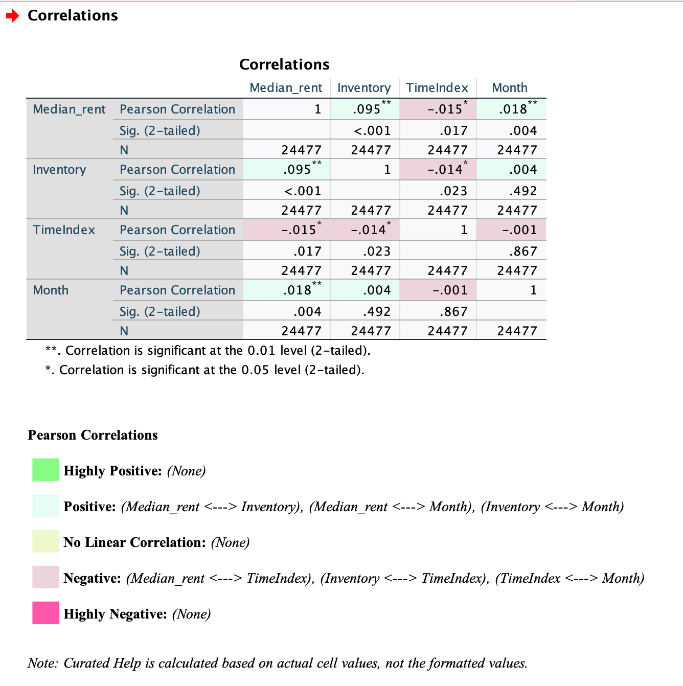
Pearson correlations between:
Median_rent/ Inventory/TimeIndex/Month
Median Rent vs. Inventory
Correlation = .095 (p < .001)
Very weak positive correlation
- When inventory increases a little, rent increases a little too.
- BUT the relationship is so small that it is not meaningful in real-world terms.
- Statistically significant only because the sample is HUGE, not because the effect is strong.
- Inventory does not meaningfully predict rent by itself. They move together slightly, but not enough to matter.
Median Rent vs. TimeIndex (time trend)
Correlation = −.015 (p = .017)
Very weak negative correlation
- This is basically zero relationship.
- Rent does not show a simple linear increase or decrease over time.
- NYC rent trends are seasonal, non-linear, and depend heavily on neighborhood and year
Median Rent vs. Month (1–12)
Correlation = .018 (p = .004)
Extremely weak positive correlation
- Rents are slightly higher in some months (usually summer).
- The effect is so tiny, it’s negligible.
Inventory vs. TimeIndex
Correlation = −.014 (p = .023)
- Inventory does not systematically rise or fall over time in a simple straight line.
Inventory vs. Month
Correlation = .004 (p = .492)
- Inventory does not change consistently by month.

Conclusion: The correlations between Median Rent and the other variables (Inventory, TimeIndex, Month) are statistically significant but extremely small (all r < .10). This indicates that none of the predictor variables have a strong simple linear relationship with rent.
The very large sample size (N = 24,477) makes small effects statistically significant, but the effect sizes are trivial.
Therefore, to understand how rent changes over time and varies across neighborhoods, a multiple regression model is required. Correlations alone are insufficient.
Scatter plots
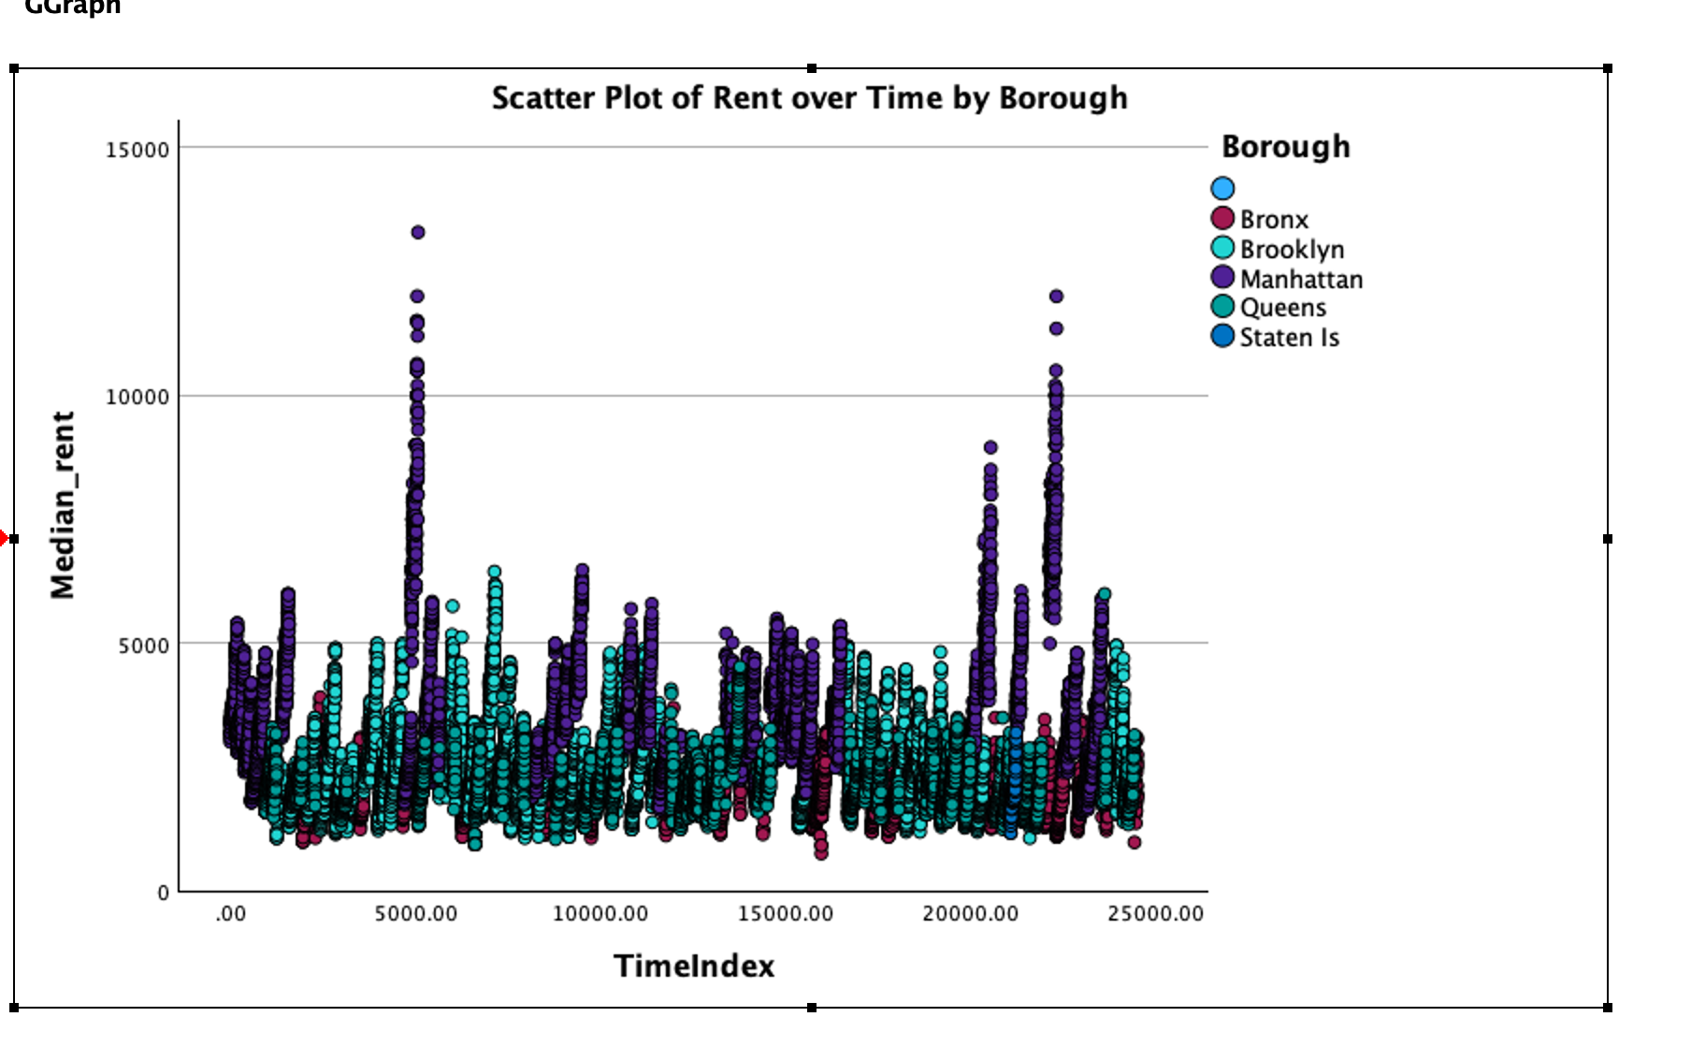
Meaning:
- Median rents stay between $2,000 and $5,000 for most of the timeline.
- There is no smooth upward or downward curve, meaning rent does NOT steadily increase or decrease over time in this raw scatter.
- Very Large Spikes = Specific Neighborhoods (Certain neighborhoods dramatically inflate the range, hiding the overall trend.)
- Neighborhood differences are MUCH stronger than time trends.
- Time alone does not explain rent changes.

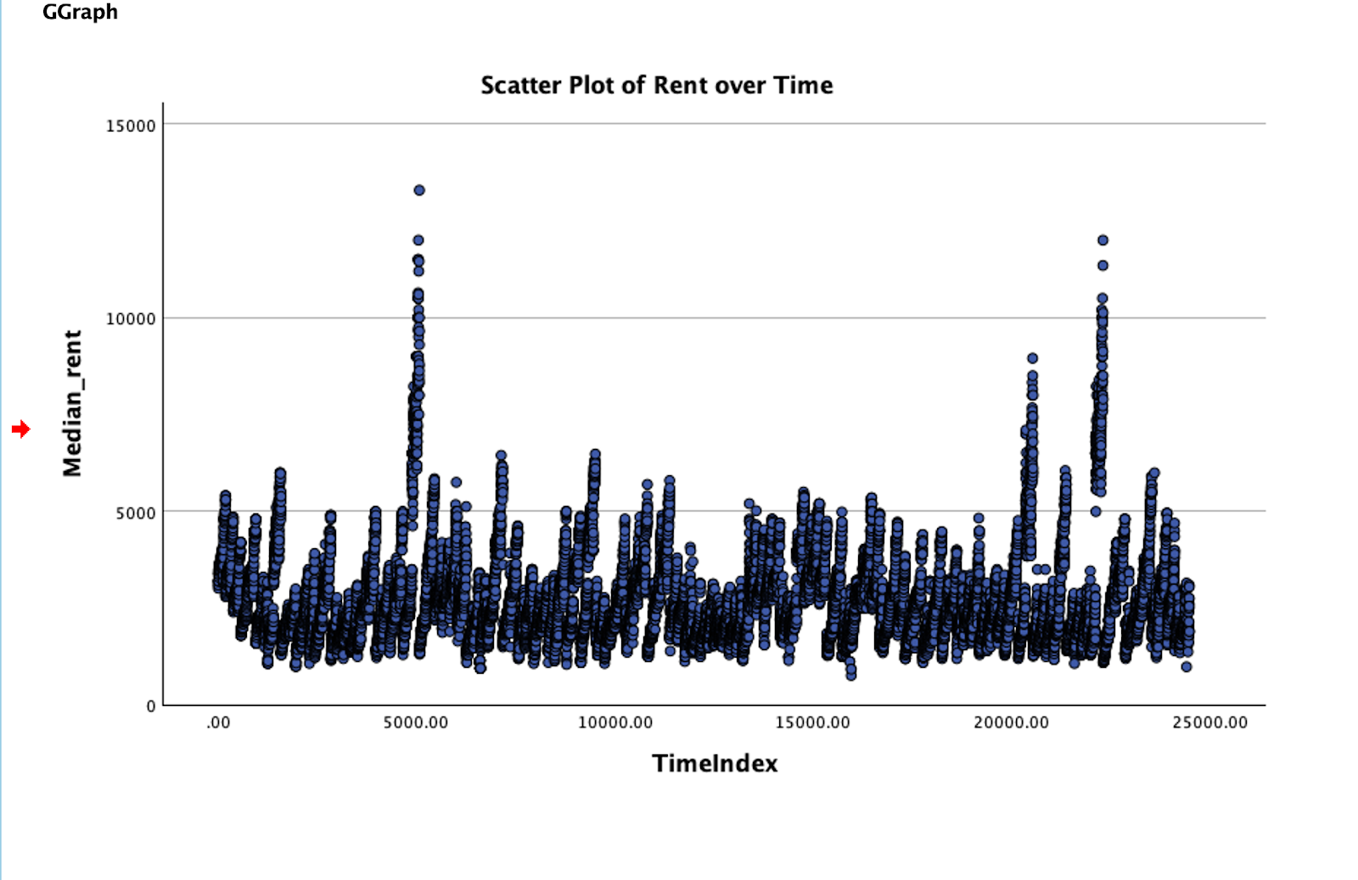

Regression model

Between-Subjects Factors
Borough_num | Value Label | N
1 | Manhattan | 6845
2 | Brooklyn | 8490
3 | Queens | 5576
4 | Bronx | 3215

Descriptive Statistics

Dependent Variable: Median_rent
Borough_num | Mean | Std. Deviation | N
Manhattan | 3678.38 | 1347.842 | 6845
Brooklyn | 2606.68 | 803.225 | 8490
Queens | 2157.28 | 473.307 | 5576
Bronx | 1889.58 | 430.966 | 3215
Total | 2711.32 | 1117.604 | 24126

Levene’s Test of Equality of Error Variances

Dependent Variable: Median_rent
F | df1 | df2 | Sig.
1409.505 | 3 | 24122 | < .001

Tests the null hypothesis that the error variance of the dependent variable is equal across groups.
Design: Intercept + TimeIndex + Year + Borough_num

Tests of Between-Subjects Effects

Dependent Variable: Median_rent
Source | Type III SS | df | Mean Square | F | Sig.
Corrected Model | 13,765,641,653.146 | 5 | 2,753,128,330.629 | 4057.178 | < .001
Intercept | 3,257,956,472.472 | 1 | 3,257,956,472.472 | 4801.124 | < .001
TimeIndex | 28,985,373.233 | 1 | 28,985,373.233 | 42.715 | < .001
Year | 3,354,477,883.575 | 1 | 3,354,477,883.575 | 4943.364 | < .001
Borough_num | 11,611,049,387.143 | 3 | 3,870,349,795.714 | 5703.584 | < .001
Error | 16,367,399,664.087 | 24120 | 678,582.076 | — | —
Total | 207,489,168,719.000 | 24126 | — | — | —
Corrected Total | 30,133,041,317.233 | 24125 | — | — | —

R Squared = .457
Adjusted R Squared = .457

Parameter Estimates

Dependent Variable: Median_rent
Parameter | B | Std. Error | t | Sig. | Lower CI | Upper CI
Intercept | -171892.464 | 2470.669 | -69.573 | < .001 | -176735.129 | -167049.798
TimeIndex | .005 | .001 | 6.536 | < .001 | .004 | .007
Year | 86.038 | 1.224 | 70.309 | < .001 | 83.639 | 88.436
[Borough_num=1] | 1932.332 | 17.773 | 108.724 | < .001 | 1897.496 | 1967.168
[Borough_num=2] | 844.138 | 17.351 | 48.651 | < .001 | 810.129 | 878.147
[Borough_num=3] | 313.445 | 18.254 | 17.172 | < .001 | 277.667 | 349.224
[Borough_num=4] | 0 | — | — | — | — | —

Observed Power
Intercept: 1.000
TimeIndex: 1.000
Year: 1.000
[Borough_num=1]: 1.000
[Borough_num=2]: 1.000
[Borough_num=3]: 1.000

Estimated Marginal Means

Dependent Variable: Median_rent
Borough_num | Mean | Std. Error | Lower CI | Upper CI
Manhattan | 3725.913 | 9.980 | 3706.352 | 3745.474
Brooklyn | 2637.719 | 9.046 | 2619.988 | 2655.451
Queens | 2107.027 | 11.116 | 2085.238 | 2128.815
Bronx | 1793.581 | 14.650 | 1764.867 | 1822.295

Covariates evaluated at TimeIndex = 12148.4799, Year = 2018.0153

Pairwise Comparisons

Dependent Variable: Median_rent
Adjustment for multiple comparisons: Bonferroni
I Borough | J Borough | Mean Diff (I–J) | Std. Error | Sig. | Lower CI | Upper CI
Manhattan | Brooklyn | 1088.194 | 13.453 | < .001 | 1052.697 | 1123.690
Manhattan | Queens | 1618.886 | 14.966 | < .001 | 1579.399 | 1658.374
Manhattan | Bronx | 1932.332 | 17.773 | < .001 | 1885.438 | 1979.225
Brooklyn | Manhattan | -1088.194 | 13.453 | < .001 | -1123.690 | -1052.697
Brooklyn | Queens | 530.693 | 14.460 | < .001 | 492.540 | 568.845
Brooklyn | Bronx | 844.138 | 17.351 | < .001 | 798.358 | 889.918
Queens | Manhattan | -1618.886 | 14.966 | < .001 | -1658.374 | -1579.399
Queens | Brooklyn | -530.693 | 14.460 | < .001 | -568.845 | -492.540
Queens | Bronx | 313.445 | 18.254 | < .001 | 265.283 | 361.608
Bronx | Manhattan | -1932.332 | 17.773 | < .001 | -1979.225 | -1885.438
Bronx | Brooklyn | -844.138 | 17.351 | < .001 | -889.918 | -798.358
Bronx | Queens | -313.445 | 18.254 | < .001 | -361.608 | -265.283

Univariate Tests

Dependent Variable: Median_rent
Sum of Squares | df | Mean Square | F | Sig.
Contrast | 11,611,049,387.143 | 3 | 3,870,349,795.714 | 5703.584
Error | 16,367,399,664.087 | 24120 | 678,582.076 | —

The F tests the effect of Borough_num.

Parameter Estimates (Robust Standard Errors)
Parameter | B | Robust Std. Error | t | Sig. | Lower CI | Upper CI
Intercept | -171892.464 | 2730.571 | -62.951 | < .001 | -177244.554 | -166540.373
TimeIndex | .005 | .001 | 6.000 | < .001 | .003 | .007
Year | 86.038 | 1.353 | 63.605 | < .001 | 83.386 | 88.689
Borough_num=1 | 1932.332 | 16.996 | 113.691 | < .001 | 1899.018 | 1965.646
Borough_num=2 | 844.138 | 9.920 | 85.099 | < .001 | 824.695 | 863.581
Borough_num=3 | 313.445 | 7.577 | 41.369 | < .001 | 298.594 | 328.297
Borough_num=4 | 0 | — | — | — | — | —

Observed Power (alpha = .05): all = 1.000

Results:
1. Does rent change over time? (TimeIndex & Year)
TimeIndex
B = .005, p < .001
Interpretation: As time passes (monthly index), rent increases slightly but significantly.
Year
B = 86.038, p < .001
Interpretation: Each additional year is associated with an average increase of $86 in median rent, after controlling for borough and inventory.
Conclusion:
Rent has been rising over time, even when you control for borough differences.
2. Do boroughs differ in average rent? (Borough_num)
Yes — very strongly.
Means (Adjusted for Time & Year):
Manhattan: $3725.91

Brooklyn: $2637.72
Queens: $2107.03
Bronx: $1793.58
Pairwise differences (all significant at p < .001):
- Manhattan > Brooklyn by $1088
- Manhattan > Queens by $1619
- Manhattan > Bronx by $1932
- Brooklyn > Queens by $531
- Brooklyn > Bronx by $844
- Queens > Bronx by $313
Conclusion:
All boroughs differ significantly from each other, with the expected ordering:
Manhattan > Brooklyn > Queens > Bronx
This pattern is clear and statistically strong (F = 5703.584, p < .001).

Overall model fit
R² = .457 (46% of variance explained)
This is very strong for housing data.
Interpretation:
Model explains nearly half of all variation in NYC rents using only time and borough.
That’s a very good model for urban economics data.
Robust Standard Errors (HC3)
Robust coefficients stayed almost identical to the regular ones.
This means:
No serious heteroskedasticity problems
Results are stable and trustworthy
Final Answer Summary:
We used a General Linear Model to predict median rent from time (TimeIndex and Year) and borough (Manhattan, Brooklyn, Queens, Bronx). The model was significant and explained 45.7% of the variance in rent (R² = .457). Rent increased significantly over time (TimeIndex: B = .005, p < .001; Year: B = 86.04, p < .001). Borough had a large effect on rent (F = 5703.584, p < .001). Adjusted means showed the expected pattern: Manhattan had the highest rents ($3726), followed by Brooklyn ($2638), Queens ($2107), and the Bronx ($1794). All pairwise differences were significant (Bonferroni-adjusted). Robust standard errors confirmed that the results were stable. Overall, rents have been rising over time and vary substantially across boroughs, with Manhattan being the most expensive and the Bronx the least expensive.

